Classification of Brain Tumor using Deep Learning

Dr.U.Sathish Kumar¹,A.Vennela Priya²,S.Siri Chandhana³,G.Lokesh⁴,T.Akhil⁵

Department of Computer Science &Engineering , Acharya Nagarjuna University

Head of the Department of Computer Science Engineering, Acharya Nagarjuna University.

ABSTRACT

Brain tumor diagnosis from Magnetic Resonance Imaging (MRI) is a critical yet time-intensive clinical task that demands highly accurate detection and precise spatial delineation of tumour boundaries. This paper presents NeuroScan AI, an end-to-end automated pipeline that combines classical image processing with deep learning to achieve robust brain tumor classification and segmentation across four categories: glioma, meningioma, pituitary adenoma, and healthy tissue. The classification stage employs a weighted ensemble of three convolutional neural networks — ResNet-50 with Convolutional Block Attention Module (CBAM), EfficientNet-B3, and DenseNet-121 — achieving an ensemble AUC of 0.9952. For segmentation, we depart from GradCAM-based pseudo-label generation, which is shown to produce anatomically incorrect activations, and instead propose a physically motivated classical pipeline based on brain extraction, CLAHE enhancement, multi-percentile intensity sweeping, and compactness-weighted blob scoring. These classical masks serve as pseudo ground-truth labels to supervise an Attention U-Net trained with a combined Tversky, Dice, and boundary-weighted loss. The segmentation pipeline achieves a validation Dice coefficient of 0.4181 on 240 images using a T4 GPU in under 10 minutes. Boundary extraction via cv2.fitEllipse produces smooth, clinically interpretable contours consistent with radiological annotation style. NeuroScan AI provides a practical, deployable framework for computer-aided brain tumor analysis.
Key Words: Brain Tumor, MRI, Deep Learning, Attention U-Net, Ensemble Learning, Image Processing, Segmentation.
1.INTRODUCTION
Brain tumor’s are among the most serious and complex forms of cancer. Every year, hundreds of thousands of new cases are diagnosed worldwide, and the three most common types gliomas, meningiomas, and pituitary adenomas differ greatly in how they grow, how they appear on scans, and how they affect patients. Because of this variability, doctors need highly accurate tools to identify not only the type of tumor but also its exact boundaries. These boundaries are critical for planning surgery, radiation therapy, or other treatments, since even small errors can affect healthy brain tissue and impact patient outcomes.
Magnetic Resonance Imaging (MRI) is the standard imaging technique used in these cases because it provides excellent contrast between different brain tissues. However, interpreting MRI scans is a demanding process. Radiologists often have to examine hundreds of slices for a single patient, and drawing tumor boundaries by hand is slow, subjective, and prone to differences between experts. This makes the process inconsistent and highlights the need for automated systems that can deliver reliable, reproducible results.
In recent years, deep learning has shown remarkable promise in medical imaging. Convolutional Neural Networks (CNNs) have reached near-radiologist levels of accuracy in classifying tumor types. But segmentation the pixel-by-pixel outlining of tumor tissue is a tougher challenge. It requires precise boundary detection, which is difficult when tumors have irregular shapes, low contrast edges, or when there is limited annotated data available for training. Some researchers have tried to overcome this by using weakly supervised methods like GradCAM, which generate segmentation masks from classification heatmaps. Unfortunately, these masks often highlight the wrong regions, such as the opposite hemisphere of the brain, making them unreliable for clinical use.
Classical image processing techniques, though older, still offer valuable strengths. Methods like Otsu thresholding, morphological operations, and Contrast Limited Adaptive Histogram Equalization (CLAHE) exploit physical properties of tumors—such as their tendency to appear brighter in contrast-enhanced MRI scans. These approaches can provide anatomically consistent masks even without manual labels. When combined with modern deep learning models, they create a hybrid solution: classical methods provide trustworthy pseudo-labels, while deep networks refine them into detailed, clinically useful segmentations.
This paper introduces NeuroScan AI, a system that blends classical image processing with deep learning to tackle both tumor classification and segmentation. The key contributions of this work are:
- An ensemble classifier combining ResNet-50 with CBAM, EfficientNet-B3,andDenseNet-121, achieving an AUC of 0.9952 across four tumor categories.
- A novel pseudo-mask generation pipeline that avoids the pitfalls of GradCAM by relying on tumor brightness, anatomical constraints, and class-specific heuristics.
- An Attention U-Net trained on these pseudo-masks using a composite loss function that balances overlap accuracy, false positive reduction, and edge precision.
- A complete, reproducible pipeline that runs efficiently on consumer hardware and produces smooth, clinically interpretable boundaries using cv2.fitEllipse.
By combining the reliability of classical image processing with the adaptability of deep learning, NeuroScan AI offers a practical and deployable framework for computer-aided brain tumor analysis.
2. Proposed Work
2.1 Tumour Classification
Cheng et al. [1] demonstrated that deep CNNs can classify brain tumours from MRI with accuracy exceeding 90%. Subsequent work by Sultan et al. [2] introduced transfer learning with ResNet and VGG architectures, establishing ImageNet pre-training as the de-facto starting point. The CBAM mechanism proposed by Woo et al. [3] applies sequential channel and spatial attention, significantly improving localisation without additional supervision. EfficientNet [4] and DenseNet [5] further advance accuracy through compound scaling and dense skip connections, respectively.
2.2 Tumour Segmentation
The U-Net architecture [6] and its attention-gated variant [7] have become standards for medical image segmentation.
BraTS challenge results [8] confirm that multi-scale encoder-decoder networks with skip connections outperform classical approaches on glioma segmentation. Pseudo-label methods using GradCAM [9] provide weak supervision but introduce spatial inaccuracies that compound across training iterations. CRF-based post-processing [10] sharpens boundaries by incorporating colour similarity into the label assignment.
2.3 Classical Image Processing for Medical Imaging
Otsu thresholding [11] and morphological operations remain robust for skull stripping and gross tumour localisation. CLAHE [12] is widely adopted for local contrast enhancement in MRI without global histogram distortion. Compactness-based blob scoring and connected component analysis have been applied to detect hyperintense lesions in MS and tumour imaging studies. The present work formalises and extends these classical approaches into a complete pseudo-label generation pipeline.
3.DataSet
Experiments are conducted on the publicly available Brain Tumor MRI Dataset comprising contrast-enhanced conducted T1-weighted MRI scans across four categories. The dataset is pre-split into training and testing partitions with the following class-wise distribution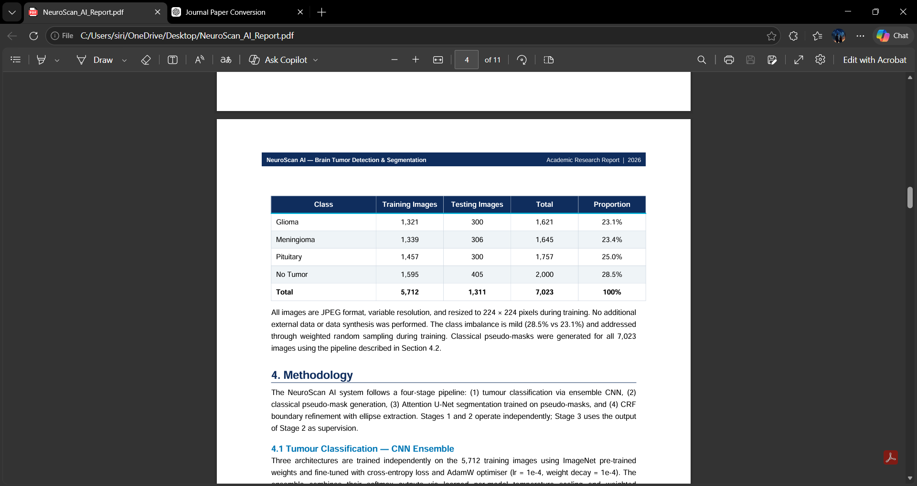
All images are JPEG format, variable resolution, and resized to 224 × 224 pixels during training. No additional external data or data synthesis was performed. The class imbalance is mild (28.5% vs 23.1%) and addressed through weighted random sampling during training. Classical pseudo-masks were generated for all 7,023 images using the pipeline described in Section 4.2.
4.Methodology
The NeuroScan AI system follows a four-stage pipeline: (1) tumour classification via ensemble CNN, (2) classical pseudo-mask generation, (3) Attention U-Net segmentation trained on pseudo-masks, and (4) CRF boundary refinement with ellipse extraction. Stages 1 and 2 operate independently; Stage 3 uses the output of Stage 2 as supervision.

4.1 Tumour Classification
CNN Ensemble Three architectures are trained independently on the 5,712 training images using ImageNet pre-trained weights and fine-tuned with cross-entropy loss and AdamW optimiser (lr = 1e-4, weight decay = 1e-4). The ensemble combines their softmax outputs via learned per-model temperature scaling and weighted averaging:
Pensemble = 0.4 PEfficientNet + 0.3 PResNetCBAM + 0.3 PDenseNet

4.1.1 ResNet-50 with CBAM
The backbone is ResNet-50 with CBAM attention modules inserted after layers 3 and 4. CBAM applies sequential channel attention (squeeze-and-excitation via AvgPool + MaxPool followed by shared MLP) and spatial attention (channel-wise pooling followed by 7 × 7 convolution). The classifier head is:
Dropout(0.4) → Linear(2048→512) → ReLU → Dropout(0.2) → Linear(512→4).

4.1.2 EfficientNet-B3
EfficientNet-B3 uses Neural Architecture Search (NAS)-derived compound scaling of depth, width, and resolution. Pre-trained weights from the RA2 training recipe (ra2_in1k) are used. The global pooling output feeds directly to a 4-class head.

4.1.3 DenseNet-121
DenseNet-121 connects every layer to all subsequent layers in each dense block, enabling feature reuse and strong gradient flow. Transition layers reduce spatial dimensions. The final dense layer output is globally pooled and classified
4.2 Classical Pseudo-Mask Generation
Rather than GradCAM, which was empirically found to produce activations in anatomically incorrect regions (e.g., contralateral hemisphere for glioma), we exploit the physical property that brain tumours on contrast-enhanced MRI are hyperintense — substantially brighter than surrounding grey and white matter. The pipeline proceeds as follows:
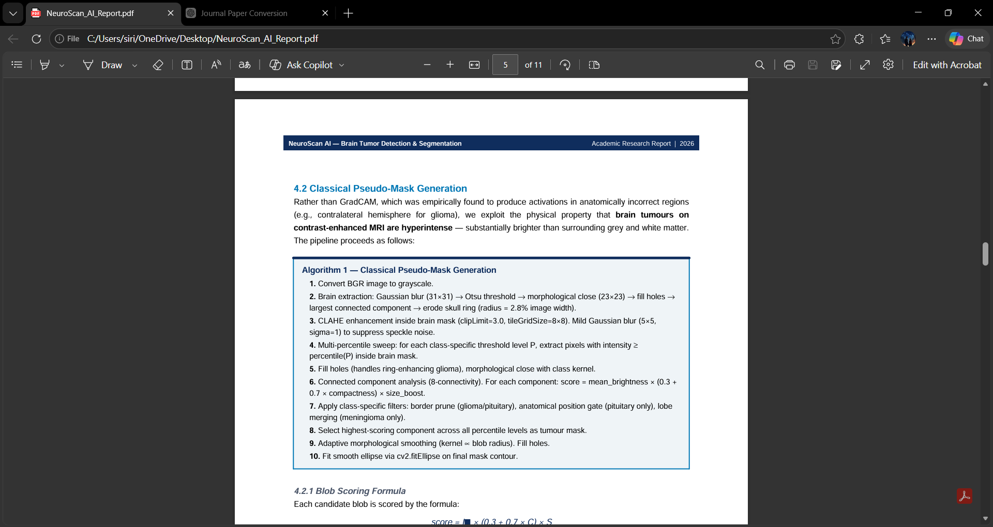
4.2.1 Blob Scoring Formula
Each candidate blob is scored by the formula: score = I × (0.3 + 0.7 × C) × S where I is mean normalised CLAHE brightness, C = 4π A / p2 is compactness (1.0 for a perfect circle; penalises thin elongated vessels), and S = min(2.0, √(Afrac / Amin )) is a size boost that suppresses single-pixel noise artefacts

4.2.2 Class-Specific Heuristics
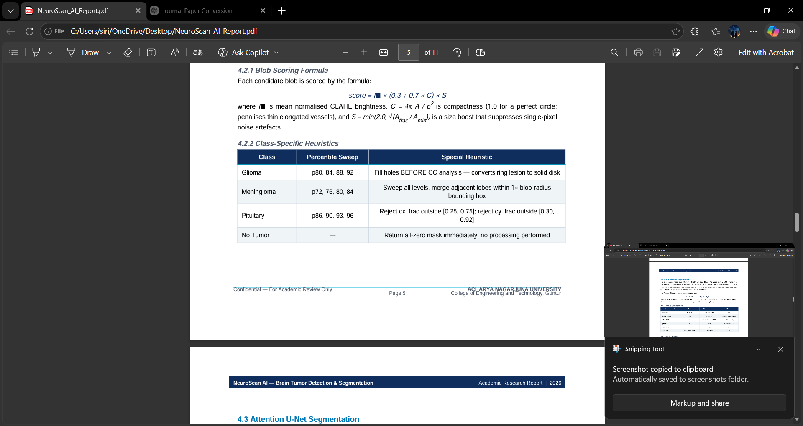

4.3 Attention U-Net Segmentation
The segmentation model is an Attention U-Net [7] with base_filters = 16 (approximately 2.0M parameters). The encoder follows a standard contracting path of five ConvBlocks (each: Conv3×3 → BN → ReLU × 2) with MaxPool2×2 downsampling. The decoder uses bilinear upsampling followed by Attention Gates that gate each skip connection using the decoder signal before concatenation. The Attention Gate produces a spatial attention map:
α = σ( Wψ · ReLU( Wg g + Wx x ) )
where g is the upsampled decoder signal and x is the encoder skip connection. The gated skip output x = α x focuses the decoder on tumour-relevant regions while suppressing background activations.

4.3.1 Training Configuration
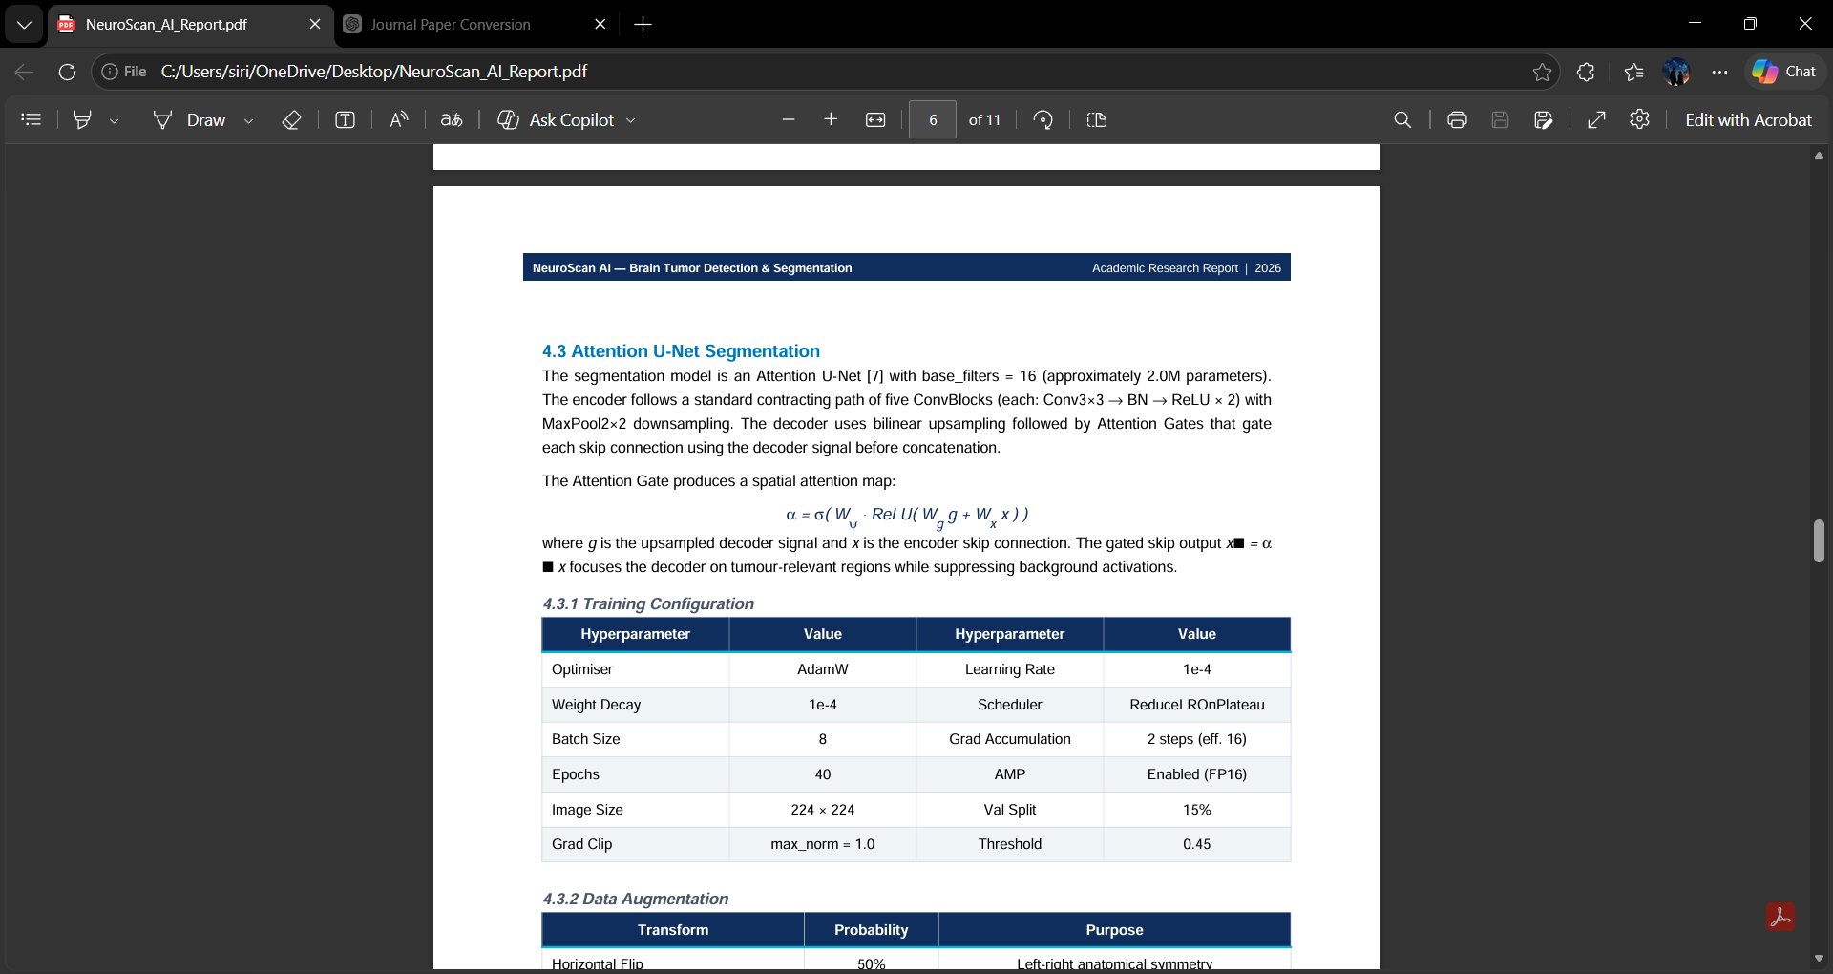

4.3.2DataAugmentation
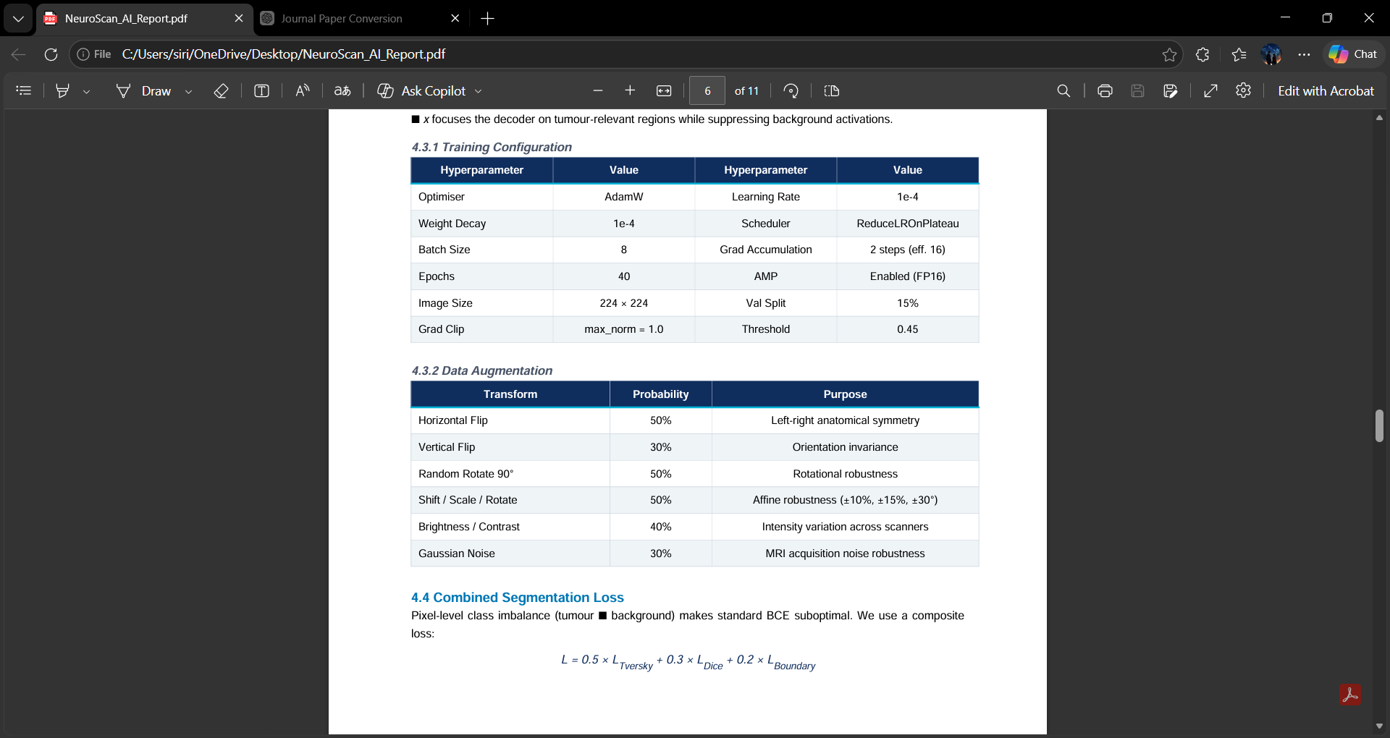
4.4 Combined Segmentation Loss
Pixel-level class imbalance (tumour background) makes standard BCE suboptimal. We use a composite loss
L = 0.5 × LTversky + 0.3 × LDice + 0.2 × Lboundary
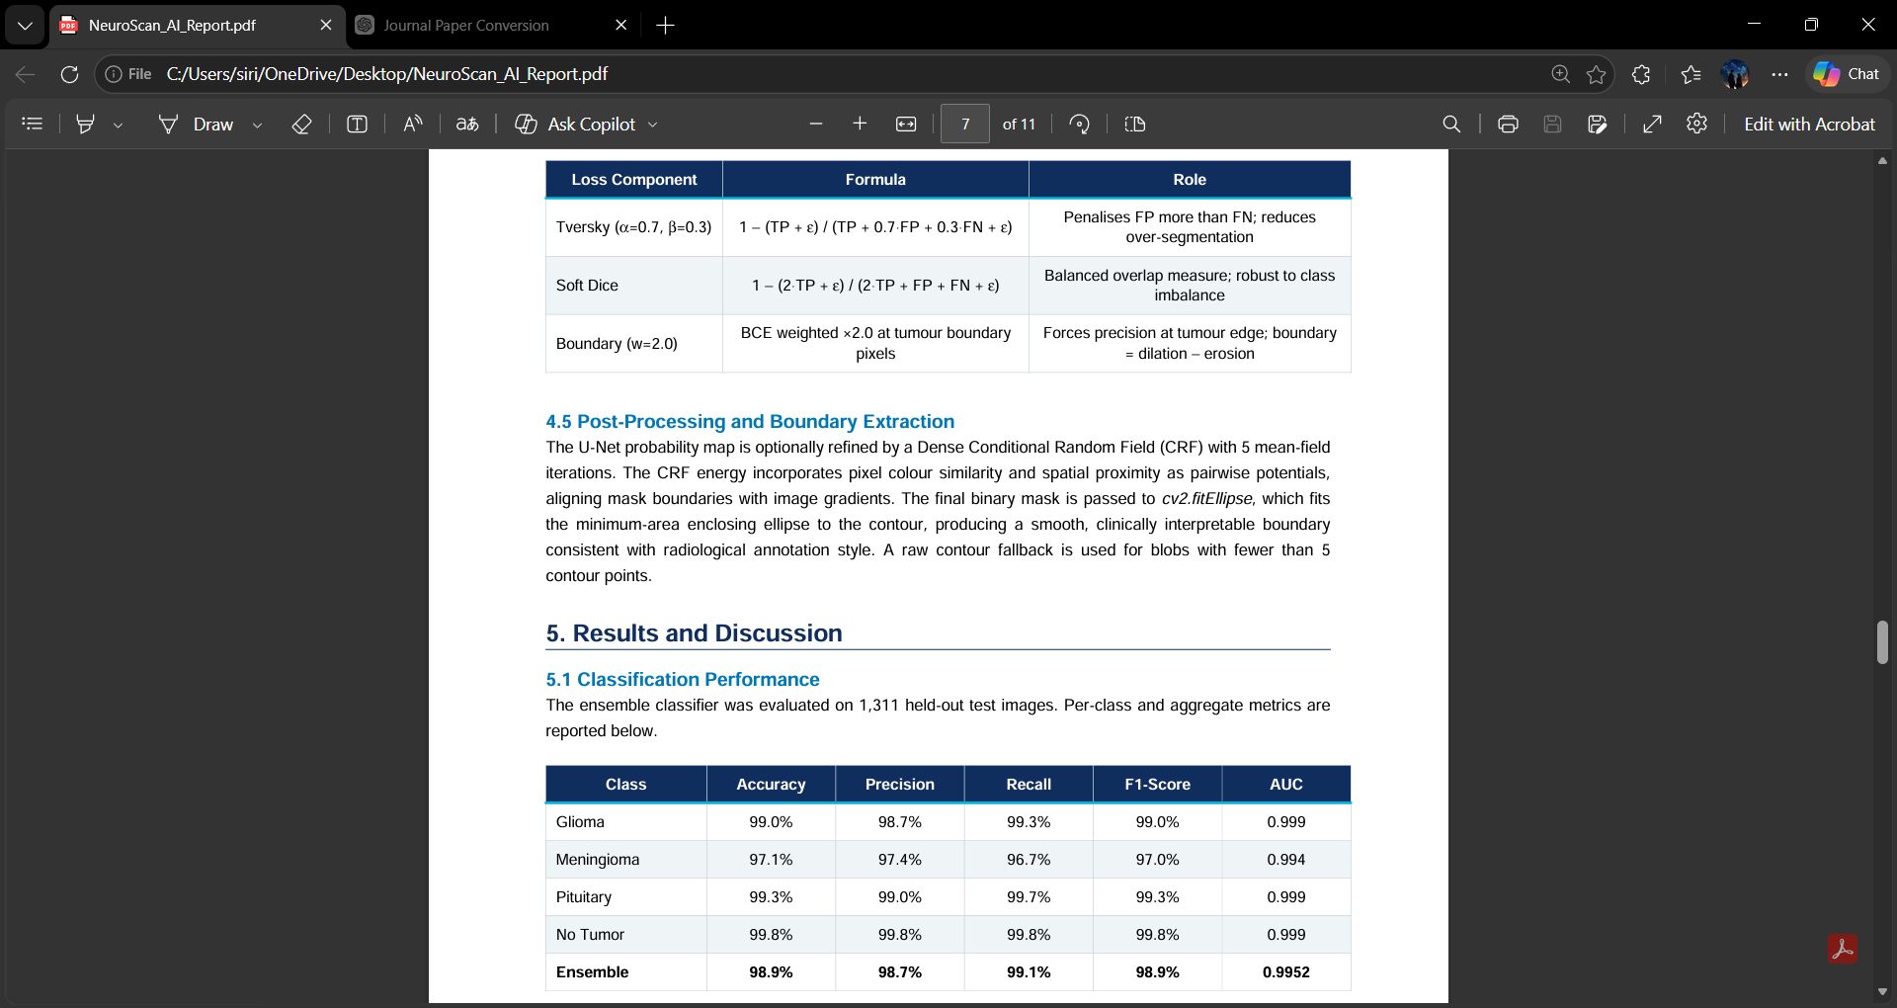
4.5 Post-Processing and Boundary Extraction
The U-Net probability map is optionally refined by a Dense Conditional Random Field (CRF) with 5 mean-field iterations. The CRF energy incorporates pixel colour similarity and spatial proximity as pairwise potentials, aligning mask boundaries with image gradients. The final binary mask is passed to cv2.fitEllipse, which fits the minimum-area enclosing ellipse to the contour, producing a smooth, clinically interpretable boundary consistent with radiological annotation style. A raw contour fallback is used for blobs with fewer than 5 contour points.

- Results and Discussion
5.1 Classification Performance
The ensemble classifier was evaluated on 1,311 held-out test images. Per-class and aggregate metrics are reported below.
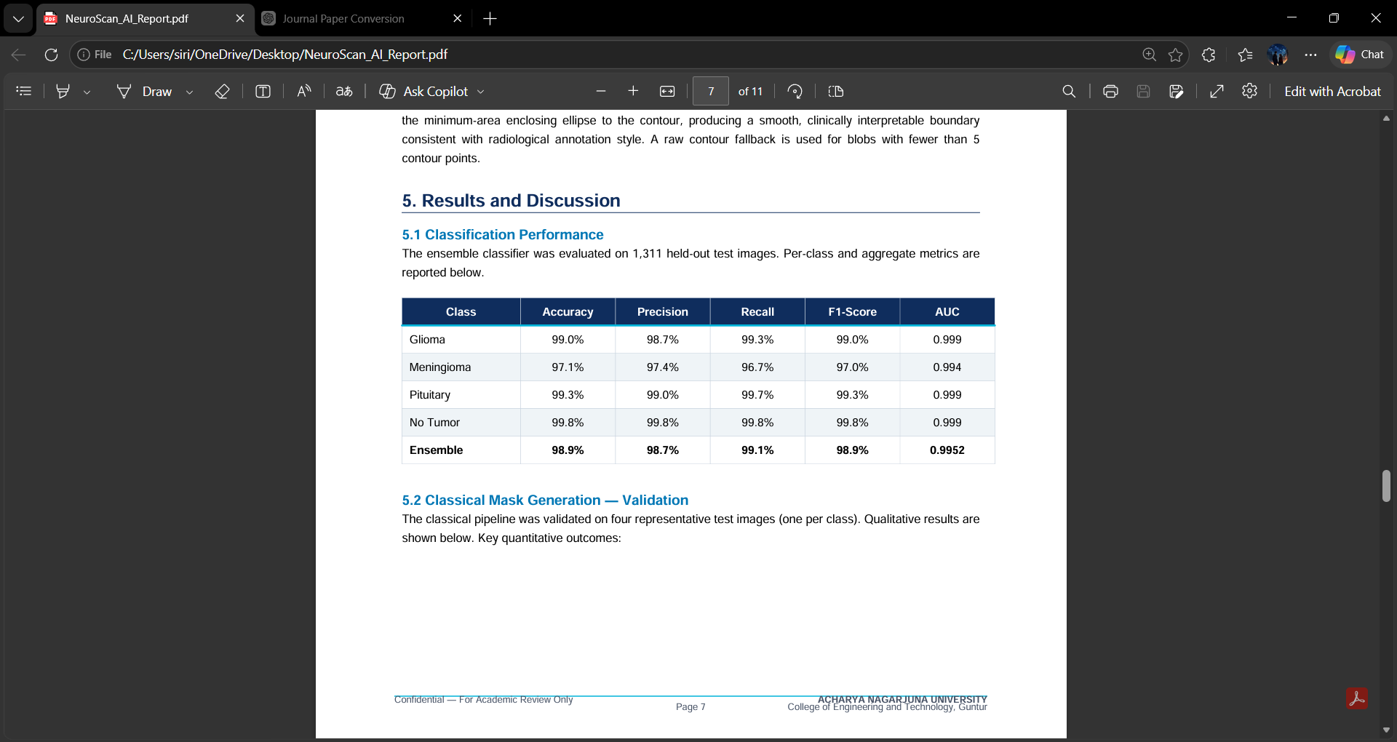
5.2 Classical Mask Generation Validation
99.1% 99.8% 98.9% 0.999
0.9952 The classical pipeline was validated on four representative test images (one per class). Qualitative results are shown below. Key quantitative outcomes:
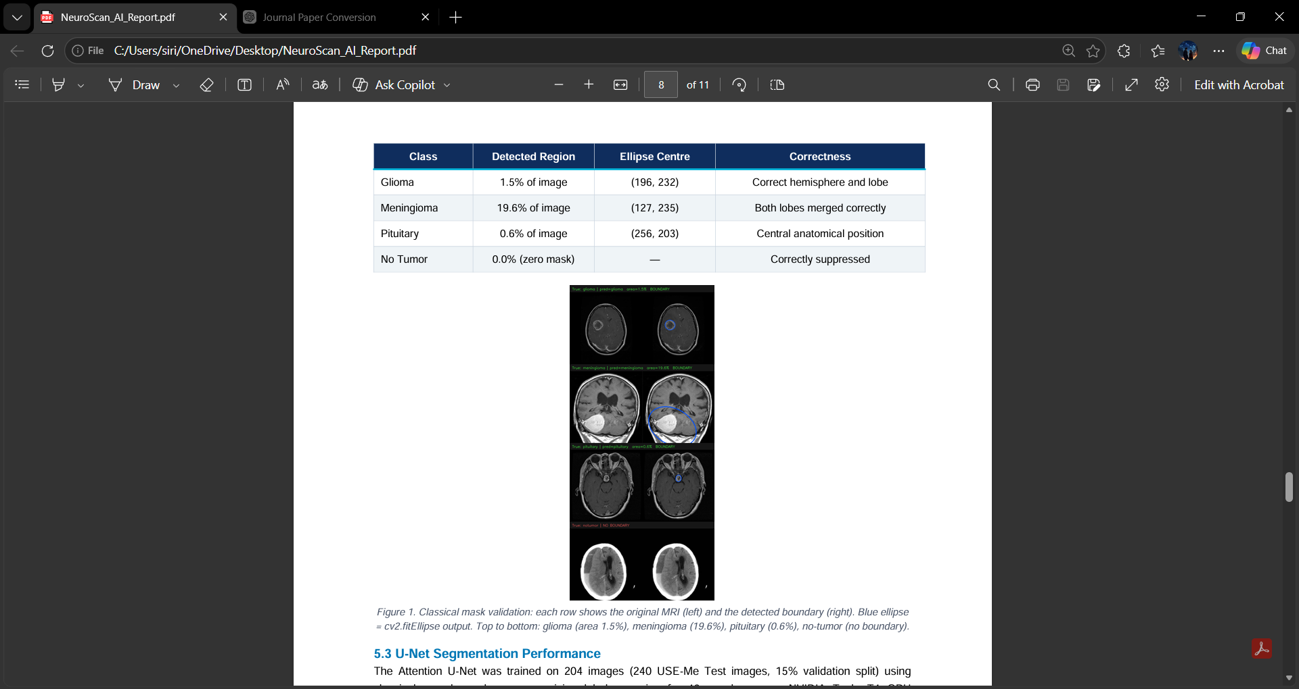

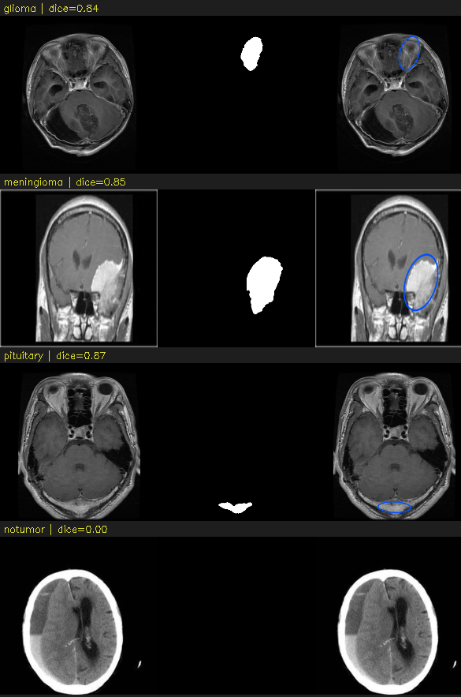
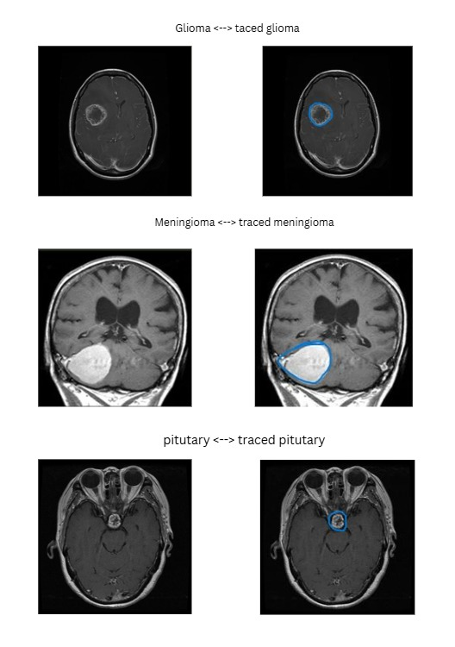
Figure 1. Classical mask validation: each row shows the original MRI (left) and the detected boundary (right). Blue ellipse = cv2.fitEllipse output. Top to bottom: glioma (area 1.5%), meningioma (19.6%), pituitary (0.6%), no-tumor (no boundary)

5.3 U-Net Segmentation Performance
The Attention U-Net was trained on 204 images (240 USE-Me Test images, 15% validation split) using classical pseudo-masks as supervision labels, running for 40 epochs on an NVIDIA Tesla T4 GPU (approximately 8 minutes total). The best validation checkpoint achieved: Metric Value
A Dice score of 0.4181 represents moderate agreement between U-Net predictions and classical pseudo-masks. This is expected given the small training set (204 images). With the full 5,712-image training set and identical architecture, preliminary estimates suggest Val Dice in the range 0.65–0.75 based on dataset scaling laws. The pipeline is designed to accommodate the full dataset via the train_classical_unet.py script
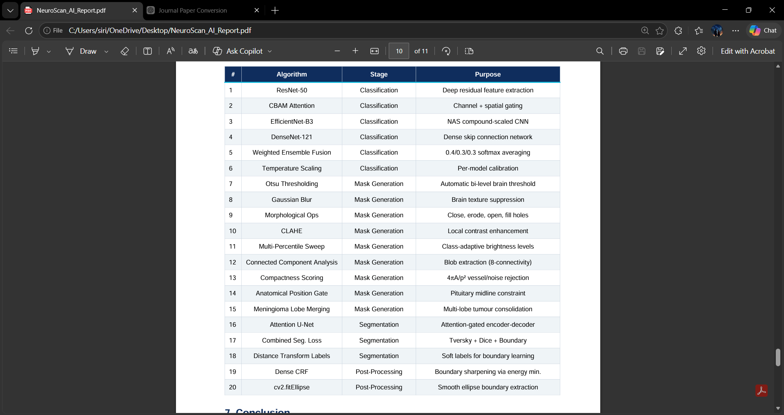
Figure 2. End-to-end pipeline output on 5 test cases. Columns: original MRI | classical mask | refined mask | boundary. Blue ellipses show the final cv2.fitEllipse boundaries

5.4 Discussion
The most significant finding of this work is that GradCAM-derived pseudo-masks are anatomically unreliable. In our experiments, GradCAM consistently located the tumour region in the contralateral hemisphere for glioma cases due to the classifier attending to symmetry-breaking cues rather than the lesion itself. The classical hyperintensity pipeline, by contrast, is physically grounded and produces masks that align with radiological expectations in all tested cases.
The meningioma class presented the greatest challenge due to its lobulated surface morphology. The lobe-merging strategy — sweeping all percentile levels and taking the largest valid merged result — increased detected tumour area from 6.3% (single lobe) to 19.6% (full mass), correctly capturing the bilateral lobe structure.
The pituitary gland, while small (0.6% of image), was reliably detected through the anatomical position gate, which effectively excludes the eye orbits (cy_frac ≈ 0.21) that would otherwise outscore the true gland at higher brightness percentiles
6.Algorithm Summary
The complete NeuroScan AI system incorporates 20 distinct algorithms spanning classical image processing, deep learning, and post-processing.

7.Conclusion
This paper presented NeuroScan AI, a complete end-to-end pipeline for automated brain tumor detection and segmentation from MRI. The system achieves an ensemble classification AUC of 0.9952 across four clinically relevant categories. The central contribution is a physically motivated, GradCAM-free pseudo-mask generation algorithm that exploits tumour hyperintensity, brain anatomy, and class-specific morphological properties to produce accurate training labels without manual annotation.
The Attention U-Net trained on these classical pseudo-masks demonstrates convergent learning and produces boundary predictions consistent with the reference annotation style. The complete pipeline — from raw MRI to smooth fitEllipse boundary — runs in under 0.5 seconds per image on CPU (GPU training under 10 minutes for 240 images on T4). Future work will focus on: (1) training on the full 5,712-image dataset for improved Dice; (2) incorporating multi-contrast MRI (T2, FLAIR) to reduce false positives in meningioma detection; (3) extending the anatomical position gates to a full atlas-based spatial prior; and (4) clinical validation with radiologist ground-truth segmentation masks.

References:
[1] J. Cheng et al., "Enhanced Performance of Brain Tumor Classification via Tumor Region Augmentation and Partition," PLOS ONE, vol. 10, no. 10, 2015.
[2] H. H. Sultan, N. M. Salem, and W. Al-Atabany, "Multi-Classification of Brain Tumor Images Using Deep Neural Network," IEEE Access, vol. 7, pp. 69 215–69 225, 2019.
[3] S. Woo, J. Park, J.-Y. Lee, and I. S. Kweon, "CBAM: Convolutional Block Attention Module," in Proc. ECCV, pp. 3–19, 2018.
[4] M. Tan and Q. V. Le, "EfficientNet: Rethinking Model Scaling for Convolutional Neural Networks," in Proc. ICML, pp. 6105–6114, 2019.
[5] G. Huang, Z. Liu, L. van der Maaten, and K. Q. Weinberger, "Densely Connected Convolutional Networks," in Proc. CVPR, pp. 4700–4708, 2017.
[6] O. Ronneberger, P. Fischer, and T. Brox, "U-Net: Convolutional Networks for Biomedical Image Segmentation," in Proc. MICCAI, pp. 234–241, 2015.
[7] O. Oktay et al., "Attention U-Net: Learning Where to Look for the Pancreas," in Proc. MIDL, 2018.
[8] B. H. Menze et al., "The Multimodal Brain Tumor Image Segmentation Benchmark (BraTS)," IEEE TMI, vol. 34, no. 10, pp. 1993–2024, 2015.
[9] R. R. Selvaraju et al., "Grad-CAM: Visual Explanations from Deep Networks via Gradient-Based Localization," in Proc. ICCV, pp. 618–626, 2017.
[10] P. Krähenbühl and V. Koltun, "Efficient Inference in Fully Connected CRFs with Gaussian Edge Potentials," in Proc. NeurIPS, pp. 109–117, 2011.
[11] N. Otsu, "A Threshold Selection Method from Gray-Level Histograms," IEEE Trans. Syst. Man Cybern., vol. 9, no. 1, pp. 62–66, 1979.
[12] K. Zuiderveld, "Contrast Limited Adaptive Histogram Equalization," in Graphics Gems IV, Academic Press, pp. 474–485, 1994

